YCCE

Vision
“To become the most preferred institution providing innovative, research and value based, professional education for the society at large”.

Mission
YCCE is committed to
- Attract best talent and create learning ambience
- Practice Innovative teaching-learning & research
- Integrate Industry-Institute Collaborations
- Nurture students towards holistic development and choicest career

Department

Vision of the Department
To be a well-known center for pursuing computer education through innovative pedagogy, value-based education and industry collaboration.

Mission of the Department
To establish learning ambience for ushering in computer engineering professionals in core and multidisciplinary arena by developing problem-solving skills through emerging technologies.

23CT1402 | Lab: Operating Systems
Name of the Student: Anushka Yede | Semester/ Section: 5 A
Roll No: 01 | Enrollment Number: 23071016

Sr. No. | COs | POs |  |  |  |  |  |  |  |  |  |  |  | PSOs
 |  | Course Outcomes | 1 | 2 | 3 | 4 | 5 | 6 | 7 | 8 | 9 | 10 | 11 | PSO 1 | PSO2
1 | CO1 | Demonstrate the ability to execute Linux process management, memory management, and shell commands to manage system resources efficiently. | 3 | 3 | 3 | - |  | - | - | - | - | - | 3 | 3
2 | CO2 | Develop programs utilizing system calls, thread programming, and page replacement algorithms to simulate and analyze operating system functionalities. | 3 | 3 | 3 | - | - | - | - | - | - | - | 3 | 3
3 | CO3 | Design and implement process scheduling, memory allocation, and deadlock detection algorithms to address real-world operating system challenges. | 3 | 3 | 3 | - |  | - | - | - | - | - | 3 | 3
 |  | Avg |  | 3 | 3 | - |  | - | - | - | - | - | 3 | 3

Practical no 2
Aim: | Execute the linux process management , memory management system call
Theory | What Is a System Call?  A system call is the method by which a program requests services from the operating system’s kernel—services that require elevated privileges, like accessing hardware, manipulating files, or managing processes. System calls serve as the essential interface between your application and the OS.  How System Calls Work  - The application invokes a library function (e.g., open() or read()).  - The system triggers a context switch from user mode to kernel mode, allowing the OS to operate with higher privilege  - The kernel executes the requested service.  - Control returns to the application in user mode, often with a return value indicating success or error.  Key Purposes & Benefits  - Security & Protection: Ensures programs can’t directly access hardware or memory, safeguarding system integrity.  - Abstraction: Developers can perform tasks like file I/O or network communication without needing low-level hardware details.  - Standardization: Provides a consistent API across different hardware and OS versions, simplifying compatibility
Process management –
Fork( ), wait( )--

#include <stdio.h>
#include <stdlib.h>
#include <unistd.h>
#include <sys/wait.h>

int main(void) {
pid_t pid = fork();

if (pid == -1) {
perror("fork failed");
exit(EXIT_FAILURE);
}
else if (pid == 0) {
// Child process
printf("Hello from the child process!\n");
_exit(EXIT_SUCCESS);
} else {
// Parent process
int status = 0;
waitpid(pid, &status, 0);
if (WIFEXITED(status)) {
printf("Child exited with status %d\n", WEXITSTATUS(status));
}
}
return EXIT_SUCCESS;
}

Memory management –

sbrk(),mmap() and munmap()-

#include <stdio.h>
#include <stdlib.h>
#include <sys/mman.h>
#include <unistd.h>
#include <string.h>
#include <sys/types.h>

int main(void) {
size_t len = 4096; // one page
void *addr = mmap(NULL, len, PROT_READ | PROT_WRITE,
MAP_ANONYMOUS | MAP_PRIVATE, -1, 0);
if (addr == MAP_FAILED) {
perror("mmap");
exit(EXIT_FAILURE);
}
strcpy(addr, "Hello, mmap!");
printf("%s\n", (char*)addr);

if (munmap(addr, len) == -1) {
perror("munmap");
exit(EXIT_FAILURE);
}
return 0;
}

Output: | Process management –  Fork( ), wait( )--  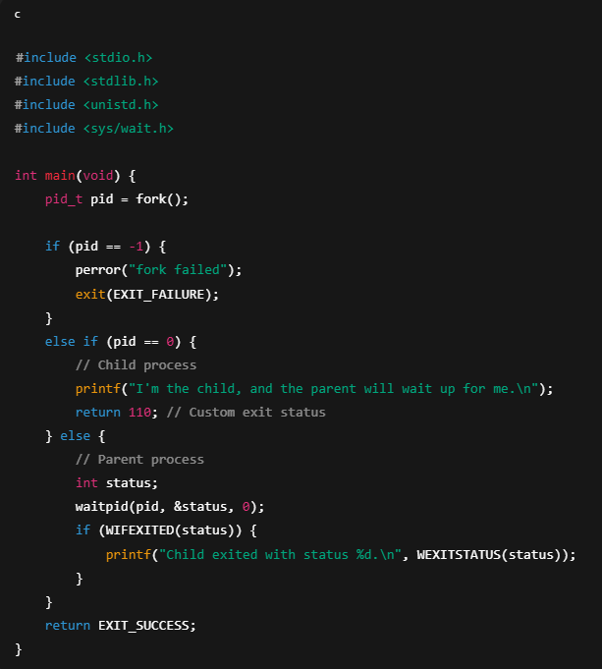  Output  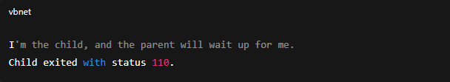  Memory management –  sbrk(),mmap() and munmap()-  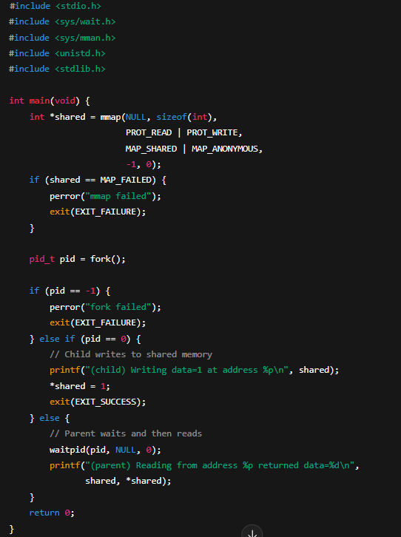  Output-  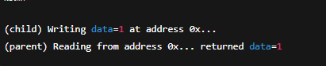
Test cases-

Process management-

- fork() + waitpid() Example

Test Case A: Child exits normally with a status (e.g., exit code 110)
Expected Behavior:
- The child prints its message, exits with status 110.
- Parent waits using waitpid(), retrieves exit status with WIFEXITED and WEXITSTATUS.

Test Case B: Child exits abnormally (e.g., via a signal like SIGSEGV)
Expected Behavior:
- Child is terminated by a signal.
- In parent: WIFEXITED(status) is false. You can use macros like WIFSIGNALED() and WTERMSIG() to detect that.

Test Case C: Zombie process scenario
If you remove the waitpid() call:
- Child exits, remains as a zombie until parent responds.
- Once parent calls wait or waitpid(), the zombie is “reaped” and cleared.

Memory management-

2. mmap() with MAP_SHARED + fork()
Test Case A: Shared memory works correctly
Expected Behavior:
- Child writes to the shared memory.
- Parent reads the updated value after waitpid().
- Both see the same data because mapping is shared.

Test Case B: Using MAP_PRIVATE instead of MAP_SHARED
Expected Behavior:
- The child writes to its private copy of memory.
- Parent remains unaffected—reading still returns the original value (e.g., 0).
- This demonstrates that private mappings are not shared.

Test Case C: Omission of waitpid()
- Without waiting, the parent may read before the child writes.
- This could lead to race conditions: parent might print “data=0” or null content, depending on OS scheduling timing.

Conclusion | Execute linux process management , memory management system call is done successfully.

